AHI User Journey Document:
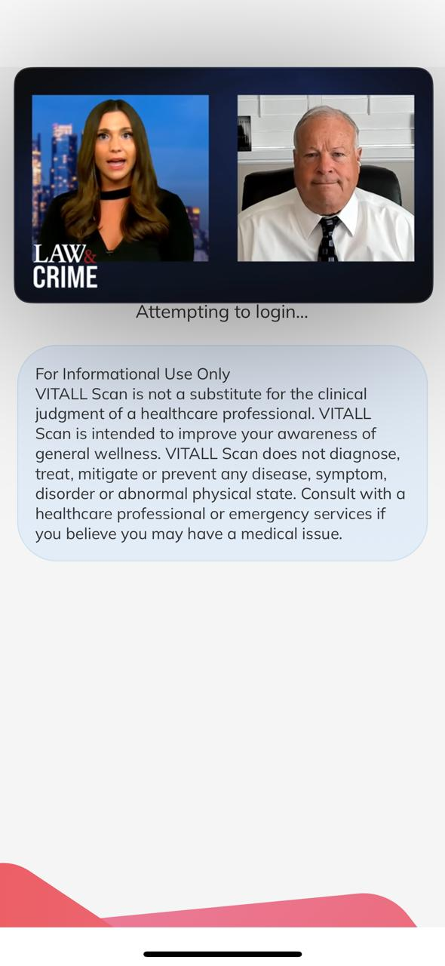
Login and Application Disclaimer:
For Informational Use Only
AHI Digital Health Assessment products and scans is not a substitute for the clinical judgment of a healthcare professional. AHI Digital Health Assessment products and scans are intended to improve your awareness and general wellness. AHI Digital Health Assessment products and scans do not diagnose, treat, mitigate, or prevent any disease, symptom, disorder or abnormal physical state. Consult with a healthcare professional or emergency services if you believe you may have a medical issue.

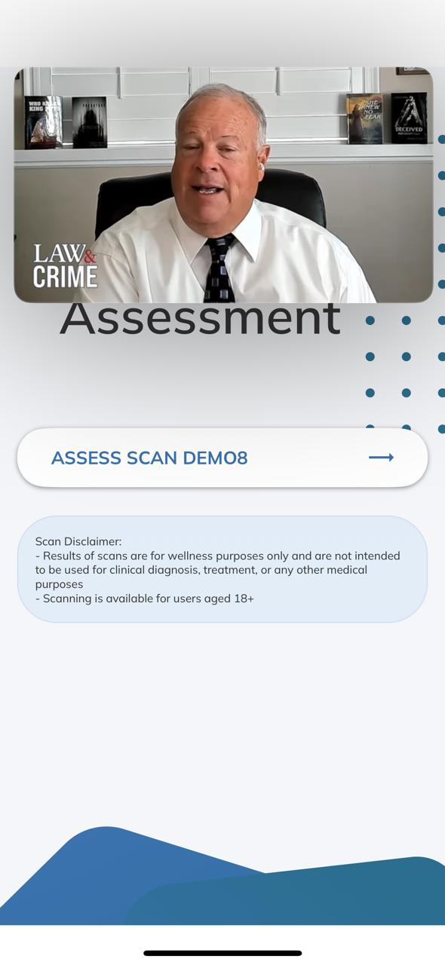

Health Assessment Disclaimer:
Scan Disclaimer:
Results of scans are for wellness purposes only and are not intended to be used for clinical diagnosis, treatment, or any other medical purposes.
Scanning is available for users aged 18+.

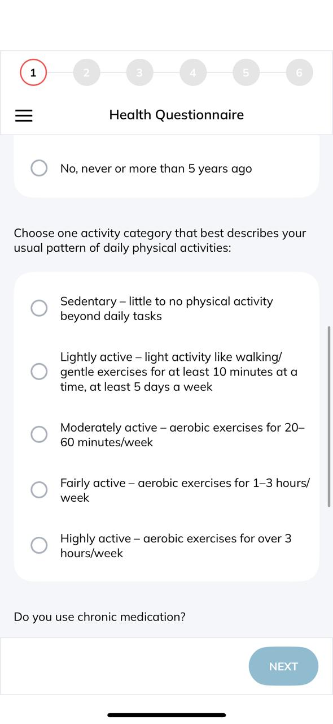
Health Questionnaire
- Height
- Weight
- Date of Birth
- Biological Sex?
  - Male
  - Female
- Do you smoke?
  - Yes, currently
  - I have in the past 5 years
  - No, never or more than 5 years ago
- Choose one activity category that best describes your usual pattern of daily physical activities:
  - Sedentary – little to no physical activity
  - Light Activity – little activity like walking/gentle exercises for at least 10 minutes at a time, at least 5 days a week.
  - Moderately Active – aerobic exercises for 20-60 minutes per week
  - Highly Active – aerobic exercises for over 3 hours per week
- Do you use chronic medication?
  - No
  - Medication for 1 – 2 diseases
  - Medication for 3 or more diseases
- Are you taking blood pressure medication?
  - Yes
  - No
- Do you have a family history of cardiovascular disease?
  - Yes
  - No
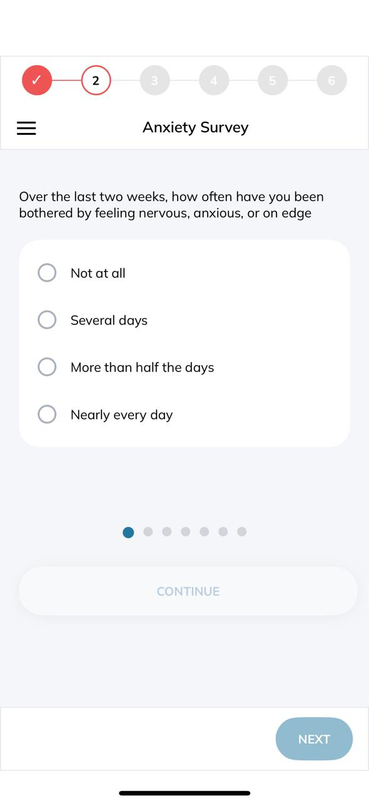

Anxiety Survey:
- Over the last two weeks, how often have you been bothered by feeling nervous, anxious, or on edge?
  - Not at all
  - Several days
  - More than half the days
  - Nearly every day
- Over the last two weeks, how often have you been bothered by not being able to stop or control worrying?
  - Not at all
  - Several days
  - More than half the days
  - Nearly every day
- Over the last two weeks, how often have you been bothered by worrying too much about different things?
  - Not at all
  - Several days
  - More than half the days
  - Nearly every day
- Over the last two weeks, how often have you been bothered by having trouble relaxing?
  - Not at all
  - Several days
  - More than half the days
  - Nearly every day
- Over the last two weeks, how often have you been bothered by feeling so restless that it is hard to sit still?
  - Not at all
  - Several days
  - More than half the days
  - Nearly every day
- Over the last two weeks, how often have you been bothered by becoming easily annoyed and irritable?
  - Not at all
  - Several days
  - More than half the days
  - Nearly every day
- Over the last two weeks, how often have you been bothered by feeling afraid, as if something awful might happen?
  - Not at all
  - Several days
  - More than half the days
  - Nearly every day

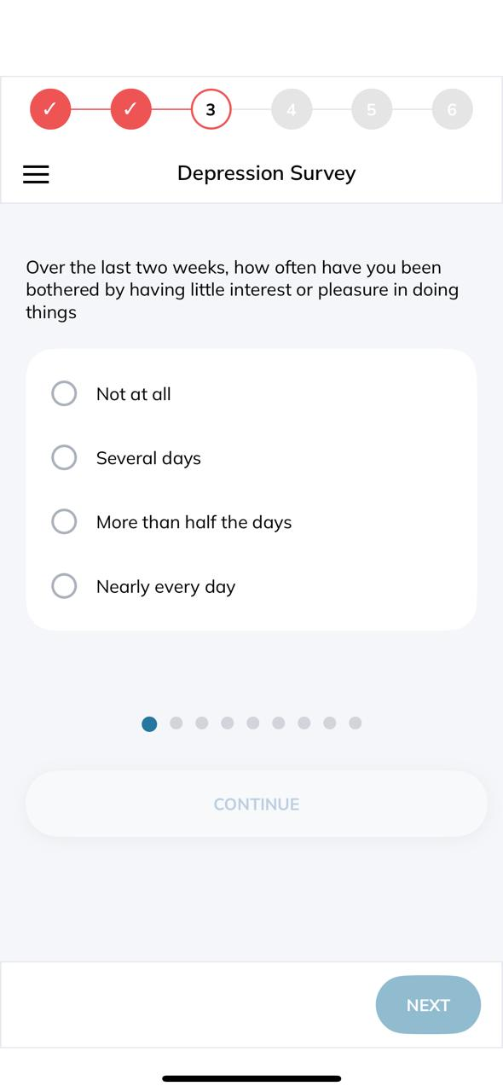
Depression Survey:
- Over the last two weeks, how often have you been bothered by having little interest or pleasure in doing things?
  - Not at all
  - Several days
  - More than half the days
  - Nearly every day
- Over the last two weeks, how often have you been bothered by feeling down, depressed, or hopeless?
  - Not at all
  - Several days
  - More than half the days
  - Nearly every day
- Over the last two weeks, how often have you been bothered by having trouble falling or staying asleep, or sleeping too much?
  - Not at all
  - Several days
  - More than half the days
  - Nearly every day
- Over the last two weeks, how often have you been bothered by feeling tired or having little energy?
  - Not at all
  - Several days
  - More than half the days
  - Nearly every day
- Over the last two weeks, how often have you been bothered by having a poor appetite or overeating?
  - Not at all
  - Several days
  - More than half the days
  - Nearly every day
- Over the last two weeks, how often have you been bothered by feeling bad about yourself – or that you are a failure or have let yourself or your family down?
  - Not at all
  - Several days
  - More than half the days
  - Nearly every day
- Over the last two weeks, how often have you been bothered by having trouble concentrating on things, such as reading the newspaper or watching television?
  - Not at all
  - Several days
  - More than half the days
  - Nearly every day
- Over the last two weeks, how often have you been bothered by moving or speaking so slowly that other people could have noticed? Or the opposite – being so fidgety or restless tat you have been moving around a lot more than usual?
  - Not at all
  - Several days
  - More than half the days
  - Nearly every day
- Over the last two weeks, how often have you been bothered by having thoughts that you would be better off dead or of hurting yourself in some way?
  - Not at all
  - Several days
  - More than half the days
  - Nearly every day
FaceScan:
Disclaimer and pre-scan text:
Taking A Face Scan
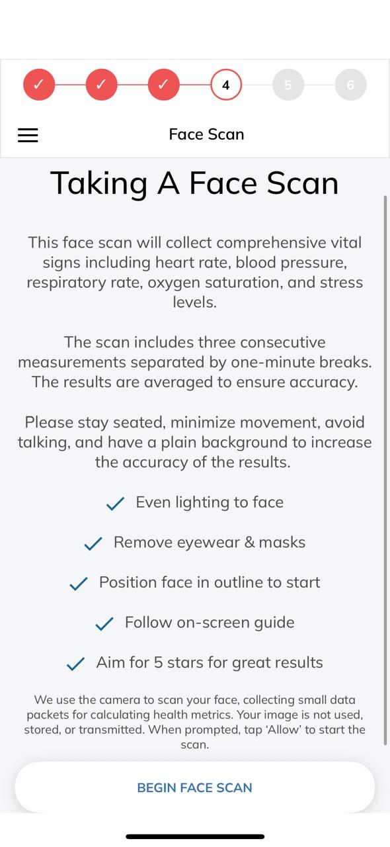
This face scan will collect comprehensive vital signs including heart rate, blood pressure, respiratory rate, oxygen saturation, and stress levels.
The scan includes three consecutive measurements separated by one-minute breaks. The results are averaged to ensure accuracy. Please stay seated, minimize movement, avoid talking, and have a plain background to increase the accuracy of the results.
- Even lighting to face
- Remove eyewear & masks
- Position face in outline to start
- Follow on-screen guide
- Aim for 5 stars for great results
We use the camera to scan your face, collecting small data packets for calculating health metrics. Your image is not used, stored, or transmitted. When prompted, tap 'Allow' to start the scan.
Activate scan as below and is done 3 times with 60 seconds break between each scan:

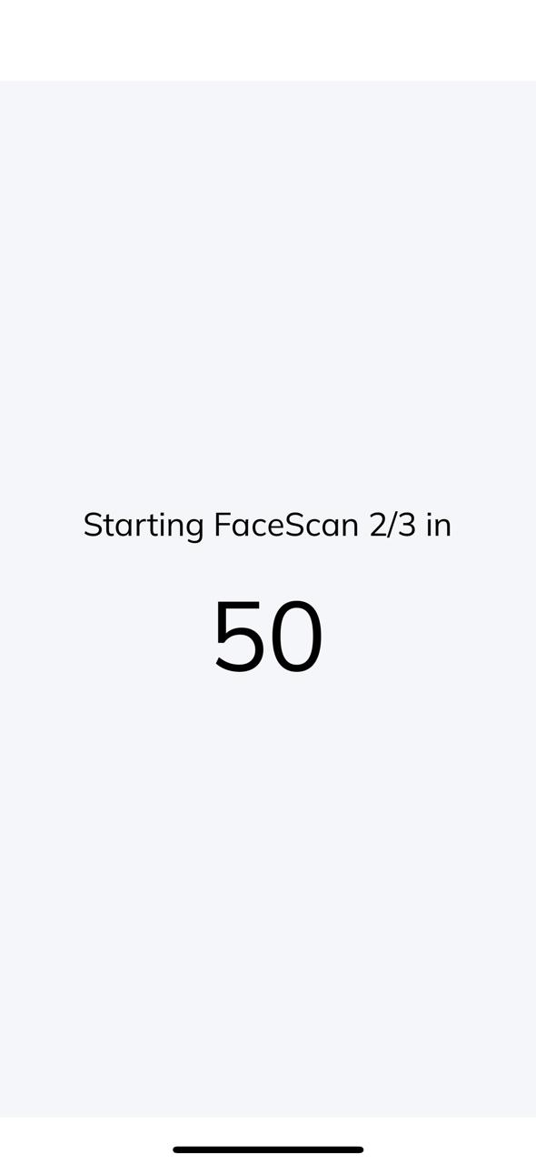
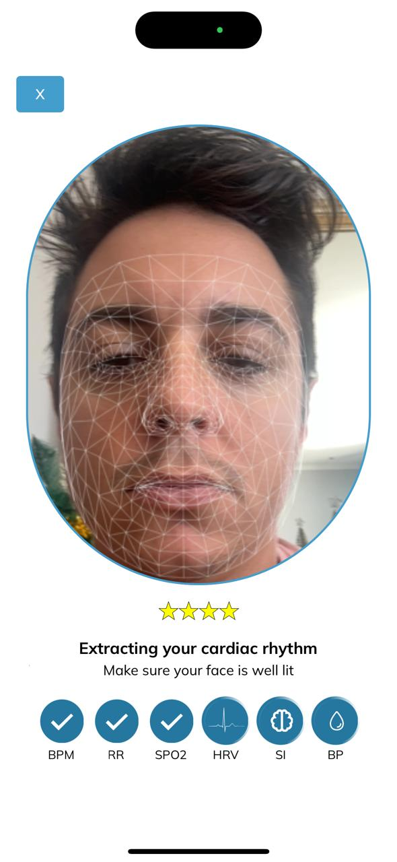

Body Scan
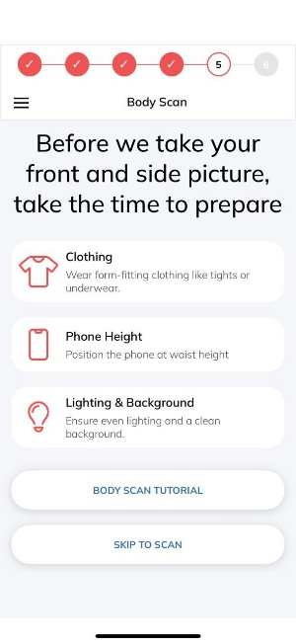

Text:
Before we take your front and side picture, take the time to prepare.
- Clothing: wear form-fitting clothing like tights or underwear
- Phone Height: Position the phone at waist height
- Lighting & Background
- Options to select tutorial / skip to scan
We use the camera to scan your face, collecting small data packets for calculating health metrics. Your image is not used, stored, or transmitted. When prompted, tap 'Allow' to start the scan.
Tutorial:
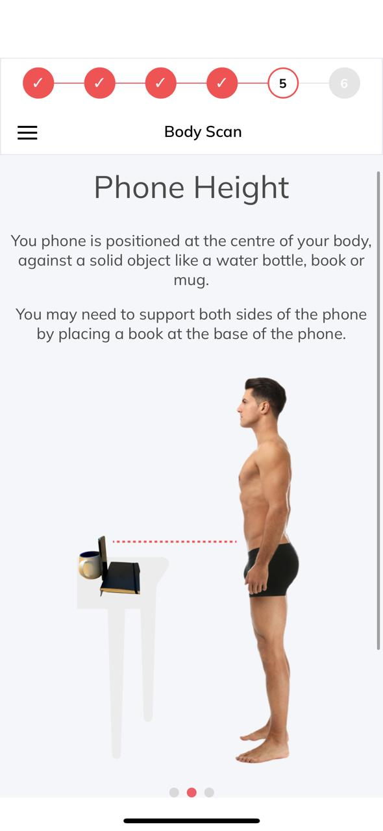
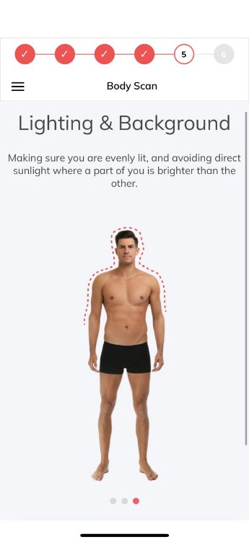
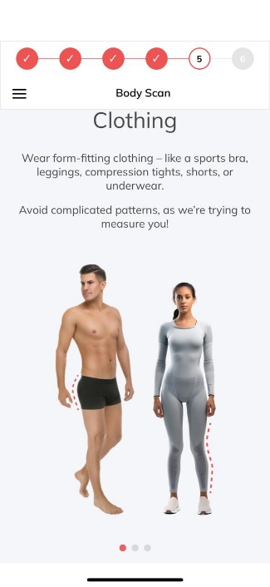

Calibration
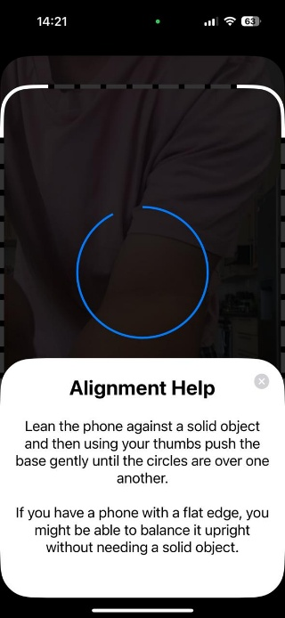

Stand facing forward
Stand facing left
Fitness Screening:
Fitness Screening Questionnaire:

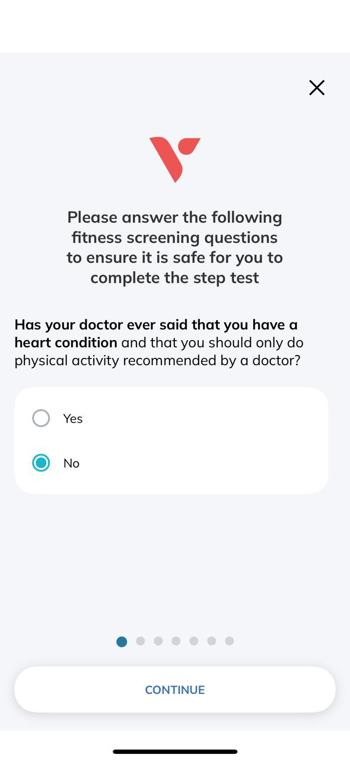
Disclaimer: Please answer the following questions to ensure it is safe for you to complete the step test.
- Has your doctor ever said that you have a heart condition and that you should only do physical activity recommended by a doctor?
  - Yes
  - No
- Do you feel pain in your chest when you do physical activity?
  - Yes
  - No
- In the past month, have you had chest pain when you were not doing physical activity?
  - Yes
  - No
- Do you lose your balance because of dizziness, or do you ever lose consciousness?
  - Yes
  - No
- Do you have a bone or joint problem that could be made worse by a change in your physical activity?
  - Yes
  - No
- Is your doctor currently prescribing drugs (for example, water pills) for your blood pressure or heart condition?
  - Yes
  - No
- Do you know of any other reason why you should not do physical activity?
  - Yes
  - No
Fitness Test Preparation text:
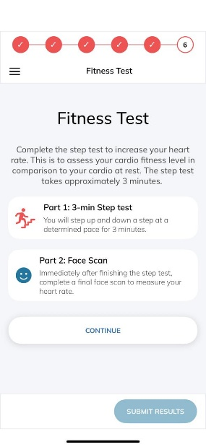
Complete the step test to increase your heart rate. This is to access your cardio fitness level in comparison to your cardio at rest. The step test takes approximately 3 minutes.
Part 1: 3-min step test
You will step up and down a step at a determined pace for 3-minues.
Part 2: Face Scan
Immediately after you finish the step test, complete a final face scan to measure your heart rate.

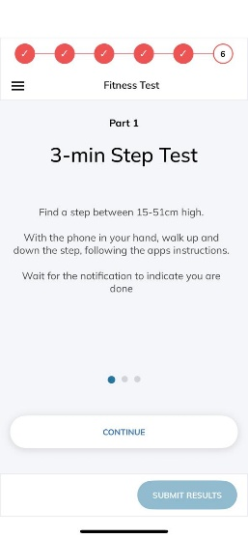
Part 1: 3-Minute Step Test
Find a step between 15-51cm high.
With the phone in your hand, walk up and down the step, following the apps instructions.
Wait for the notification to indicate you are done.

Part 1: 3-Minute Step Test
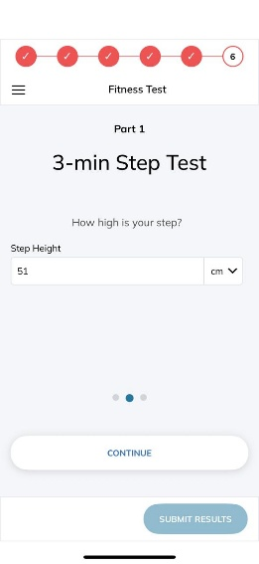
How high is your step?
Cm/inch dropdown and Step height input field

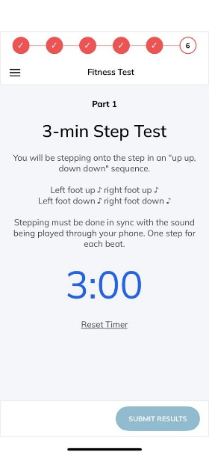
Part 1: 3-minute step test
You will be stepping onto the step in an “up up, down down” sequence.
Left foot up, right foot up
Left foot down, right foot down
Stepping must be done in sync with the sound being played through your phone. One step for each beat.
“3:00” timer with a reset timer button.

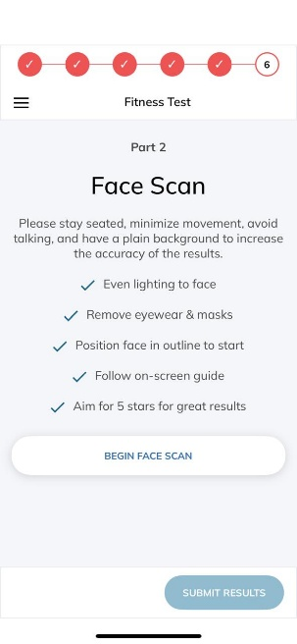
Part 2: Face Scan

Please stay seated, minimize movement, avoid talking, and have a plain background to increase the accuracy of the results.
- Even lighting to face
- Remove eyewear & masks
- Position face in outline to start
- Follow on-screen guide
- Aim for 5 stars for great results

Last step is reporting
